Name_____________________________________

ELEMENTS OF DESIGN

Elements of Art (Design)-

Name the 7 Elements
________________________________
________________________________
________________________________
________________________________
________________________________
________________________________
________________________________

What is the one I said to change from the traditional art to digital art.

What are the two types of shapes?

What is the pure color called? _________________________

What is a hue that has had white added? ________________________

What is a hue that has had black added? __________________________

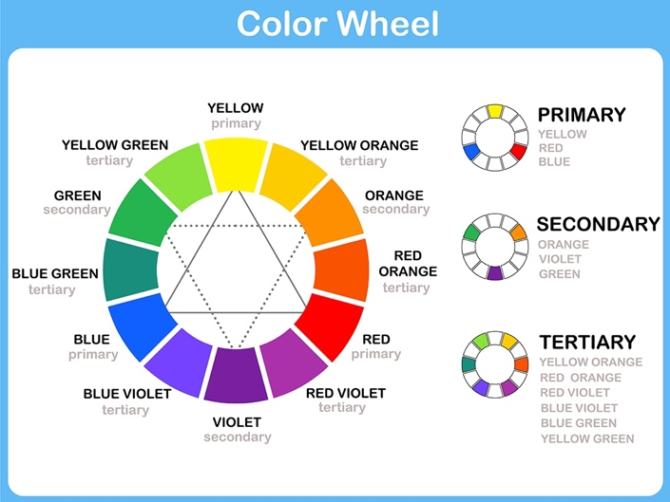

Define the following colors

Primary

Secondary

Tertiary

Complementary

Analogous

Value
What is monochromatic

Space

Positive Space

Negative Space

Texture

Tactile

Optical

